- Welcome (Live Hybrid Meeting)
- Update on the Crook’s Fire with Sarah Clawson, Jake Guadiana and James Robbins
  - James Robbins representative of the Central West Zone Type 3 Team explained the progression of the fire and suppression tactics still in place. The fire is 96% contained and the size of approximately 9402 Acres.
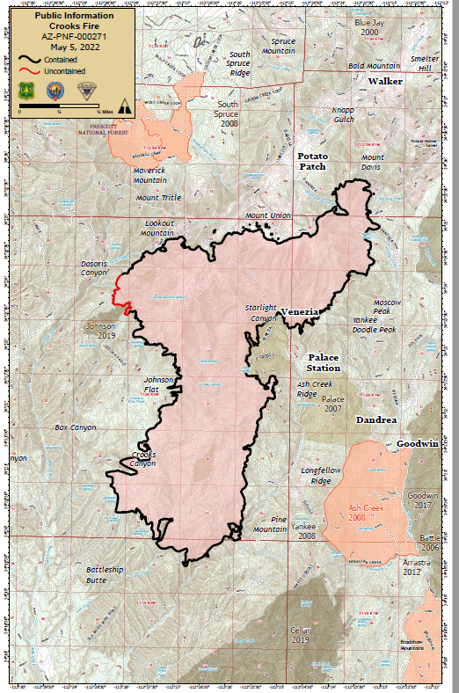
- Sarah Clawson District Ranger of the Prescott National Forest, Bradshaw and Chino Valley Ranger District, and Jake Guadiana State Safety Manager for the Arizona Department of Forestry and Fire Management shared their experiences with the Crook Fire
  - The mitigation of Camp Kippa saved the communities of Potato Patch and Mountain Pine Acres
  - As community members, the most important thing you can do is to create defensible space around your home and property that creates a safe environment for the firefighters to take a stand to fight the fire and attempt to save your property.
  - The question often asked is why there are so many more fires so close to the town. Actually, our town has encroached upon the forest taking away the fire break that used to exist.
- 50/50 Drawing
  - $59.00 was collected. After the winning ticket was drawn ½-$29.00 was donated back by Paul Beck

- Approval of April 2022 Minutes (Motion/Vote by acclamation)
  - Was approved by acclamation

- Treasurer and Grant Reports (Accept/Vote by acclamation)
  - Was accepted by acclamation

- Agency Reports
  - Marlyn VanKeuren-Yesterday at the County Board of Supervisors Meeting presented the Wildfire Preparedness Month Proclamation to Russ Shumate of AZ DFFM and to Bob Betts who accepted for Shirley Howell.
  - Derrick Piper from AZ DFFM-reported on recent activities around the state. With the fires, it has been more difficult to manage events due to lack of manpower and equipment. Showed Stage 1 Fire Restrictions.
  - Ray Paiz-Peeples Valley-reported on equipment and manpower out on fires around the region.
    - Mitigation has slowed down as crews are out helping with the fire.
  - K.C. Yowell and Ansgar Mitchell reported for PNF.
    - Stage 1 fire restrictions are in place on the Prescott National Forest and State Trust Lands within Yavapai County. Campfires are restricted to developed campsites only and smoking is only allowed inside a building or vehicle. Target shooting and fireworks are prohibited on both the Prescott National Forest and all State Trust land.
    - Discussed how important it was to have those areas that were mitigated while trying to control the fire.
  - Jon Jones-Yavapai County Emergency Management-relayed how the evacuation of one of the camps close to the fire was executed without any issues and after the campers spent one night at the Findley Center were returned home the next day.
  - Dori Booth – Sedona Fire wanted to relate the success oF the 19th annual fuel mitigation days. They are looking forward to participating in the 2023 Expo and to bringing Yavapai Firewise to the other side of the mountain.
  - LASER-Abby Harbicht – Explained that volunteers are working 24/7 to house and care for large animals evacuated from the fire area. All is going as planned. They even have chickens, ducks, and a rooster visiting the facility at the County Fair Grounds.

- Organizational Chart and Open Positions Update
  - Are still looking to fill the Marketing, Recording Secretary, and Development Director positions

- 2022 Events – 1 min
  - Wildfire Expo – April 23rd
  - YCCA Home and Garden Show – April 29, 30 & May 1
    - Thank you to the volunteers who signed up to help with set-up, tear-down, and to staff the PAWUIC booths at both of these events. A special thanks to Hugh Vallely, who was present throughout both events and did whatever was asked and more! Also, a special thank you to Jerry and Marty Borgelt who took responsibility for set-up and running the booth at the EXPO, supporting Lois throughout the event!

  - Dewey-Humboldt – 2nd Annual DHFW Wildland Fire Safety Event and Book Contest-May 14-Mortimer Farms
    - With Dewey-Humboldt Firewise encompassing the entire town, this Firewise event is a true educational and celebratory event. We encourage all to attend.

- Presentation -Tony Merriman-National Weather Service-Flagstaff
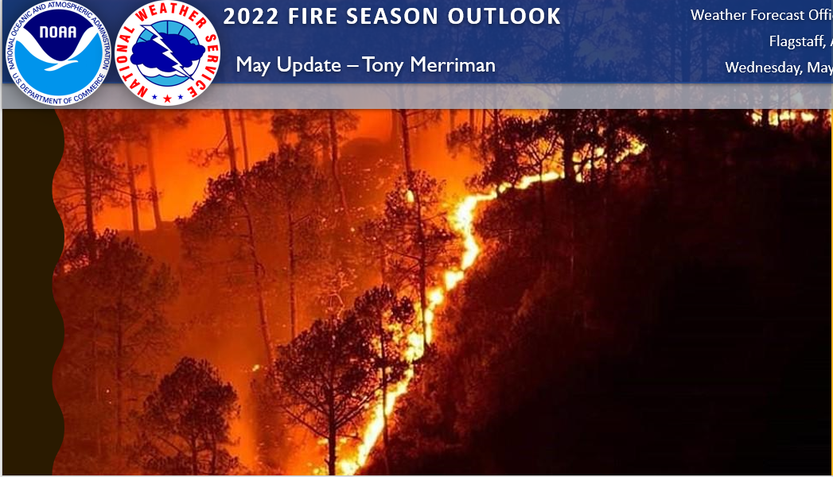

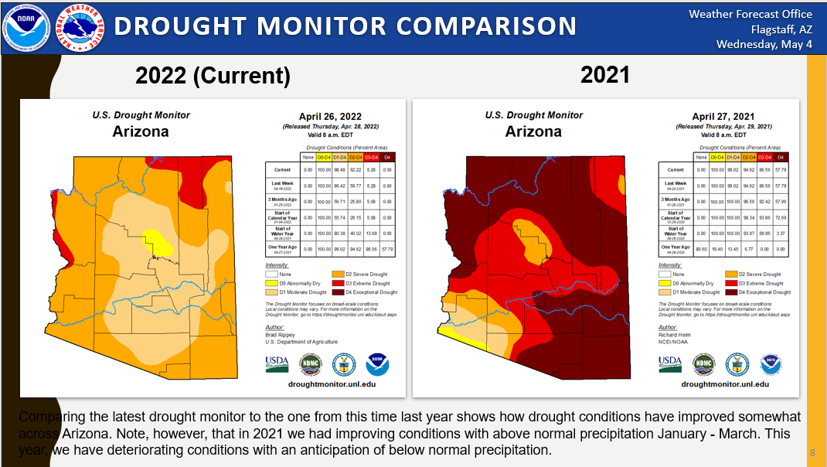

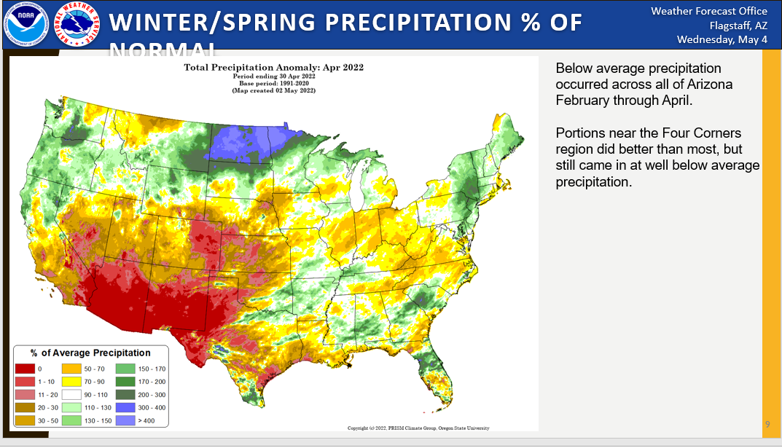

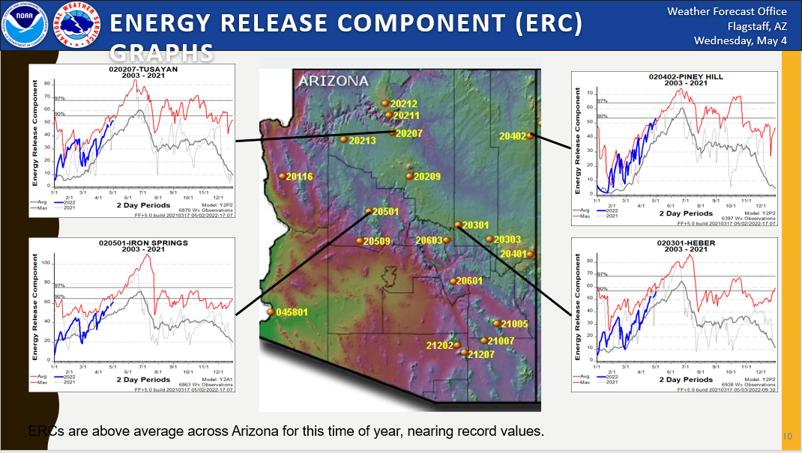

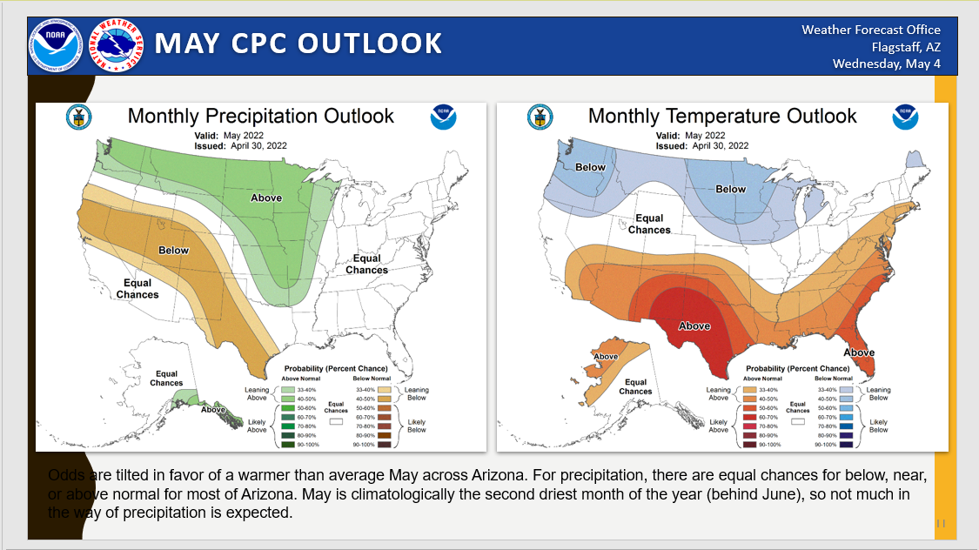

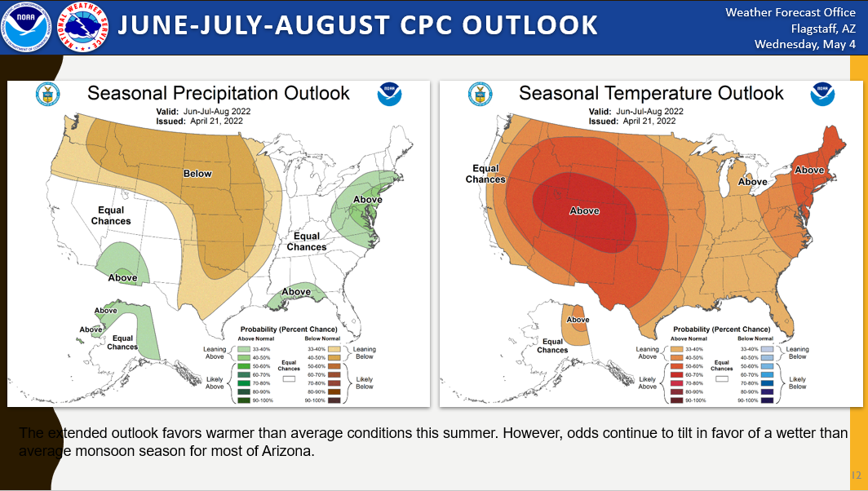

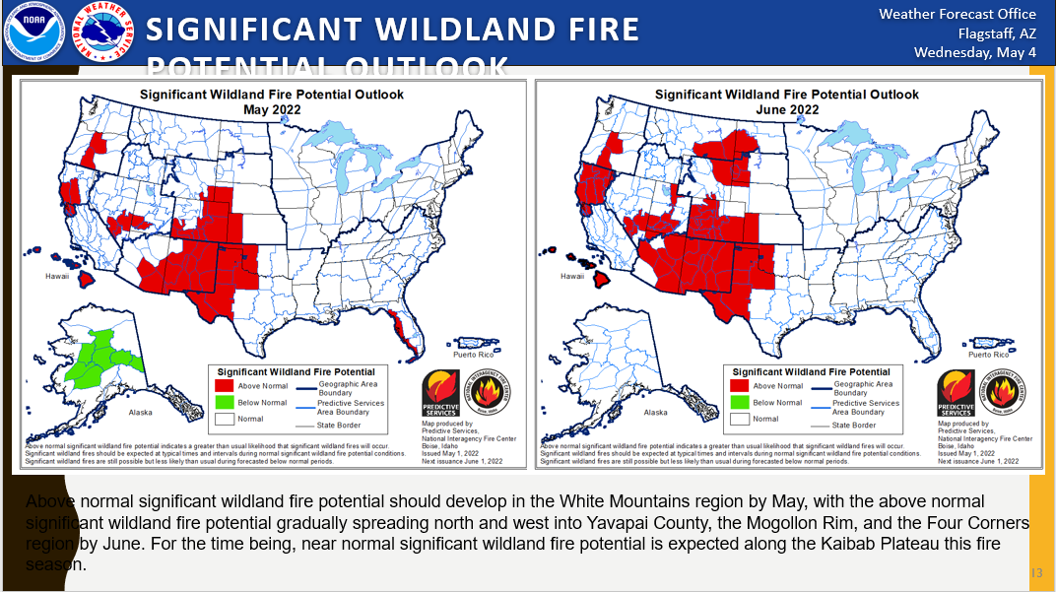

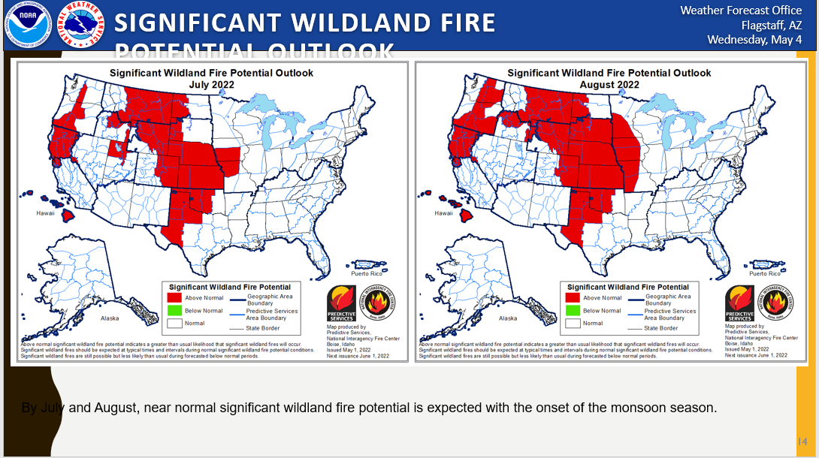

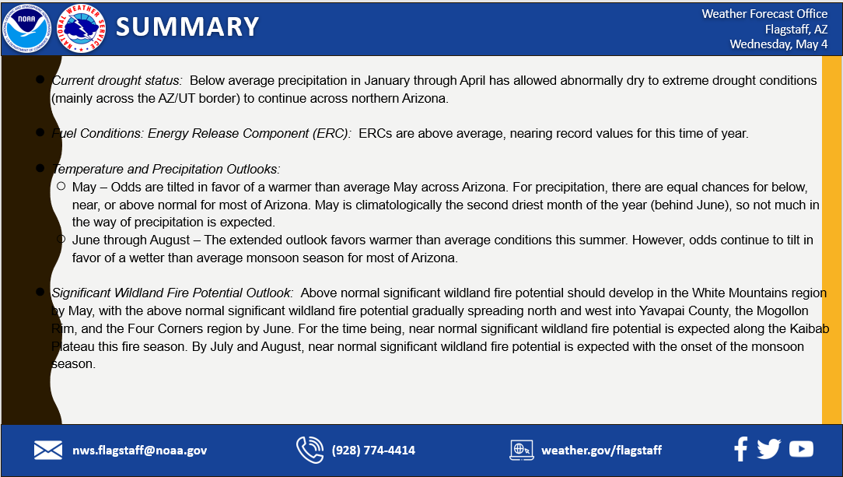

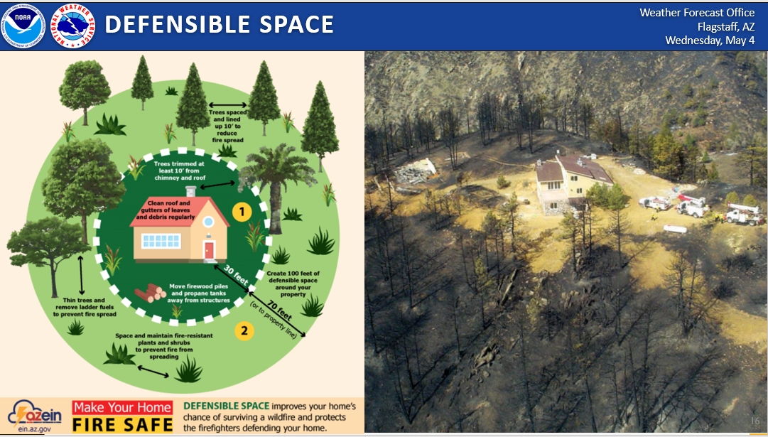

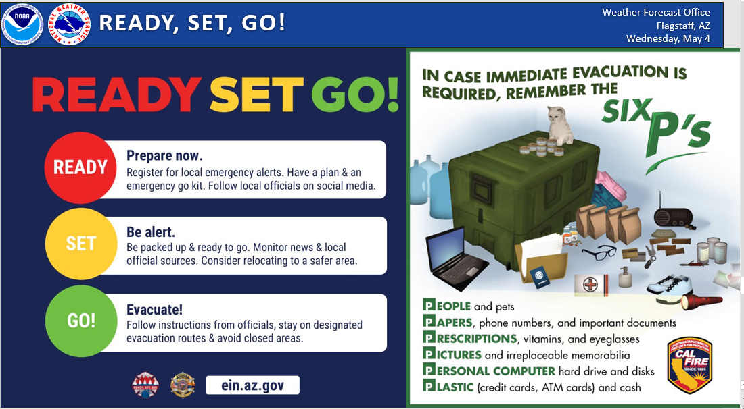
  - The National Weather Service is also looking for Storm Spotters. There will be a presentation at Embry Riddle Monday May 6:00 PM
- The link below has all the pertinent information about the SKYWARN program for Northern Arizona, and the schedule for this year so far.

- https://www.weather.gov/fgz/skywarn2022

SKYWARN is a program that trains volunteers to help keep their local communities safe by providing timely and accurate reports of monsoon and winter weather to the National Weather Service. In the program you’ll learn about:
- The basics of thunderstorm development
- The fundamentals of storm structure
- Identifying potential severe weather features
- How to report severe weather
- Basic severe weather safety
Please feel free to join us at any one of these sessions!
- For more information go to https://www.weather.gov/SKYWARN
- Communities Highlights – Open to Group
  - Debbie Miller -Dewey Humboldt
    - Have their May 14 event coming up and are working on a few details
    - The Expo was great and liked having the PR staff from the Crook Fire there with a big map of the fire which drew a big crowd.
      - Handed out over 100 fire helmets to children
    - Spent some time at the Home & Garden show and met with one of our contest winners.
  - Elaine Chambers – Mountain Club
    - Having a Pine needle pick up on May 20th,
    - Firewise Picnic on June 18th with Rick Chase in attendance (hopefully)
    - Going to assess common areas
  - Dan Russell – Prescott Lakes
    - Working to assess properties and get folks involved with defensible space

- General Open Discussion –
  - Jim Campbell wanted to thank APS for mitigating under the large Utility Line that runs through their community.
- Announcements/Adjournment
  - Meeting was adjourned at 9:36
  - Our next meeting will be Thursday June 2, 2022 8:00 AM Macklin Building

IN ATTENDANCE-Macklin Building-24
Abby Harbicht | PAWUIC/LASER | Dennis Shaw | The Ranch
Lois Hoskinson | PAWUIC-Admin | Hugh Vallely | PAWUIC
Shirley Howell | PAWUIC/Grants | K.C. Yowell | USFS
James Robbins | CWZ Team | Geraldine Keenan | PAWUIC
Ron Weiss | Santa Fe Springs | Marty Borgelt | Highland Pines
Al West | Southview | Jerry Borgelt | Highland Pines
Wm. Hartley | Cathedral Pines | Matt Rust | DFFM
Jim Campbell | Pinon Oaks | Paul Beck | Kingswood 3,4, & 5
Jon Jones | YCOEM | Bob Betts | Hidden Valley
Larry Gray | Southview | Chuck Silveira | Ponderosa Park
Tony Merriman | National Weather Service | Don Schafer | Cathedral Pines
Loren Bykerk | Walker | Ray Paiz | Peeples Valley
Sarah Clawson | PNF | Jake Guadiana | DFFM
 | IN ATTENDANCE Zoom-30
Derrick Piper | AZ DFFM | Carl Whiting | Jerome FD
Harry Oberg | YC Board of Supervisors | Elaine Chambers | Mountain Club
Beckie Simmie | Pinon Oaks | Miles Graybill | PFD Forestry Crew
Dan Russell | Prescott Lakes | Tom DiCamillo | Walker
Mary Ann Clark | Manzanita | Isiah Keeme | PFD Forest Fuels
Judy Egan | Quail Hollow | Marty Zytkowski | Prescott Skyline
Donna Forster | Rancho Vista Hills | 1-714-267-3727
Debbie Miller | D-H Firewise | Tom Knapp | Deputy Chief-Fire Marshal, PFD
Bill Fields | Oro Flame Mine | Christy Awtry | BOS
David Misencik | Rancho Vista Hills | Jim Zimmerman | Pinon Oaks
Phil Gerlings | Mt Tritle-Groom Creek | Donna Fagan | Vista del Cerro
Jim Poore | Mountain Club | Marlyn Van Keuren | BOS
Phil Goode | Mayor | Mark Russell | Timber Ridge
Rick Chase | CAFMA | Steve Canter | Groom Creek
Russell Lafayette | Prescott Lakes | Dori Booth | Fire Marshal Sedona

