Link to April 6, Zoom Meeting
https://us02web.zoom.us/rec/share/kt9e1Ne_SFL6CKFUauDe69_7FwR2ILE6kQa4XqPVCMATPYe8NAvrfowm0aRepERz.VXHBvXzh2D7CHqbF
Passcode:Vt4$k%LK

- Live/Hybrid Meeting - Tom call to order at 8:08
- Gift Card Raffle – Gift Card winner: Greg Wanket
- Approval of March Minutes - approved by acclamation

Open Items (Old Business)

- Tom reminded members that we do not solve problems, but can help with getting people to the right organization (specifically - Slash Piles person was connected with the correct agency)
- Treasurer and Grants Reports, Budget 2023
  - Budget Report will be for one month previous – see slide summary
- Nominating Committee Update - Vice Chair and Treasurer
- April 22nd Expo – Volunteer positions filled but Need attendance
- Marketing Plan Task Force Volunteers

New Business

- Agency Reports
- AZ-DFFM Andrew Dropik – Jack Pine project white spar trail 2419 – 50 of 525 acres done
- LASER - Abbey – sheltering for barn animals, training started, implemented practice, old fairground chino valley equestrian - LASER contact:
- Peeples Valley – Ray – not available April 22 (fund raiser) – phase 2 completed – tank 17 project continue – hand thinning throughout district – many requests for machinery
- AZ-DFFM - Matt Rust – Firewise accessory course at Police (20), Attending StoneRidge Firewise day and will have a booth, and the same with Dewey-Humboldt Don’t get burned. feel free to reach out to Matt to confer (mrust@dffm.az.gov)
- Piles in Skull Valley (completed 40 acres),
- Prescott – Myles – Groom Creek, Quinuis, and Constellation trailhead, Turley trail head, still chipping in city of Prescott
- Prescott fire chief - Durre, significant process in personnel, Wildfire Risk Reduction Coordinator and Fire Adapted Communities to be posted soon,
- Prescott National Forest
  - Ben Roe – many new positions, Machine thinning in Camp Wood 450 acres (Williamson Valley) Black Jack mastication started x acres (xxx)
  - Xxx Fuel Shop – prescribed fires 5 areas; many weather delays, but now good 1000 acres of pile burning in past few weeks; hand thinning bulls project, Wilhoit mastication 7000 acres; getting ready for fall prescribe fires
  - Ansgar Mitchell – starting new personnel at stations; 14-15 Basin Operation Drill (senator hwy + test fires in area) … we have webpage, Facebook, twitter, etc.
  - Levi Duffey field
  - Joe Connolly – was on Prescott Hot Shot crew;
- Yavapai County Board of Supervisors - Craig Brown – Proclamation May Firewise Month; worried about grassland fires this summer, Community Cleanup in Paulden – April free-slash at transfer station (no bags), YC is going to purchase a Mastication machine, so expect more roadside work.
- Emergency Management – Ashley – dealing with flooding + fires, training event, Planning event with partners. Sign-up for AlertYavapai, April 14-15 trail opts, StoneRidge, Wildfire Expo, evacuation zones dialogue continues, Meeting for Camp ground preparedness
- Donna – grant opportunities; inflation reduction grant for tree planting (due at end of May)

Guest Presentation – 2023 Weather Outlook

- Jeremy – warming trend, week of above normal (warming), fine fuel & grass fires likely in summer, next storm system is dry with winds (drying things out) nws.flagstaff@noaa.gov; Weather.gov.Flagstaff
- Monsoon – no indicators of onset or precipitation estimates; expecting warming monsoon temps;
- Very wet past 12 months (increase 200%)
- Next 3 months: anticipate below normal precipitation; anticipate above normal temps; Wildland Fire Outlook: normal to below normal;

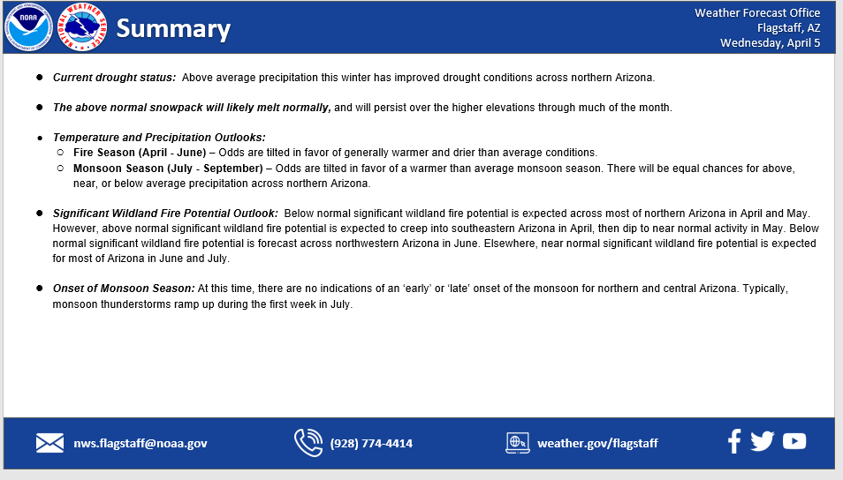

- Guest Presentation – Sarah Vincent, M.Ed., Education Director Highlands Center for Natural History “Forest health and Fire Ecology Education for All Ages”
- Wildfire Education; Thank you to First Responders & help during Crook’s Fire;
- Visit for no admission fee – Trails connected to PNF, Leeds certified, off-grid;
- To help children & adults discover the wonders of nature and become wise caretakers of land…
- Adult Education programs & presentations; school field trips; community education stops on trails; Festivals & events;
- Youth Education: controlled experiments; games; Hands on work (creating seed balls for recovering)

- Education diagram insert

- Announcements: Upcoming Events
  - How to apply, amend grants – next month AFTER meeting
  - Sign-up sheets on back table to volunteer for the Don’t Get Burned at Mortimer Farms, and the Home and Garden Show in May – if you want to help, please call Lois
  - Expo – April 22ND 9:00 – 2:00
  - Don’t Get Burned May 6th, 20:00 to 1;00
  - Home & Garden Show - Friday May 19TH to Saturday May 20TH 9:00 – 5:00, Sunday May 21ST 9:00 – 3:00
  - NFPA-Firewise Festival - Founding Fathers – October - TBA
  - Holiday Parade – December 2ND
- Mathew Brennan - Slash Pile near Thumb Butte – taken care of piles
- Steven Cutting – Certified Arborist - Pine Lakes – weather may be impacting/killing bark beetle.

- Jerry presentation – Wildfire Expo
  - Community Boards – selected a few for display (11)
  - Jerry will contact to get their community board

- Adjournment
- Next meeting Thursday, May 4
- Adjournment at 9:36
- 40-IN ATTENDANCE-Freeman Building
Tom Davis | PAWUIC/Chairman | Fred Heggestad | YCOEM
Lois Hoskinson | PAWUIC-Admin | John Jones | YCOEM
Shirley Howell | PAWUIC/Grants | Ashley Alquist | YCOEM
Julius Koenigsknecht | PAWUIC/Secretary-StoneRidge | Elaine Chambers | The Mountain Club
Dave Soto | PAWUIC/Vice-Chair | Margie Ferrucci | SYFD
Dennis Shaw | Hidden Valley | Jerry Borgelt | Highland Pines
Jim Campbell | Pinon Oaks | Dan Russell | Prescot Lakes
Mike Spencer | Prescott Foothills East | Loren Bykerk | Walker
Ernest Manzanedo | GCFD | Matthew Gordon | GCFD
Ron Weiss | Santa Fe Springs | Al West | Southview
Steven Cutting | Pine Lakes | Greg Kidd | Kingswood 1 & 2
Donna Fagan | Vista del Cerro | Tony Merriman | NWS Flagstaff
Jeremy Mazon | NWS Flagstaff | Lamont Ban | NWS Flagstaff
Greg Wanket | Southview HOA | Holger Durre | PFD
Tom Knapp | PFD | Marty Borgelt | Highland Pines
Levi Guffey | PNF | Russ LaFayette | Prescott Lakes
Andrew Dropik | DFFM | Chris Espinosa | YCOEM
Mary Kelley | Quail Hollow HOA | Miles Graybill | PFD
Ben Roe | PNF | Joe Connelly | PNF
Mike Curry | AZ DFFM | Angus Hill | Crown King

- 23-ZOOM-Freeman Building
Sara Clawson | PNF | Jim Zimmerman | Pinon Oaks
Abby Harbicht | Laser | Barbara Fox-Thomas | YCBOS
Bob Betts | Hidden Valley Ranch | Carlos Payan | BLM-Phoenix
Catherine Knox- | Coffee Pots at Sedona | Daniels, I Phone
Dave |  | Debbie Miller | D-H
Elaine Chambers | Mountain Club | Heather Stevens
Jerome Fire Dept | Carl | Mark Russell | TinberRidge
Marlyn Van Keuren | YC BOS | Mary Ann Clark | PAWUIC Social Media
Mike and Ronnie Donovan | D-H | Ray Paiz | Peeples Valley RD
Richard Jackson | Oak Knolls | Rick Contrearas | Cottonwood Fire Marshal
Ron Jakola | Jeep Posse | Steve Lombardo | PAWUIC-Community Liaison

